Intelligent Search of Vendor and Material

Step 1:-
Create one Vendor Master and one Material Master

Step 2:-
Open Transaction ME21N (Create Purchase Order)

Step 3:-
Test Case Data
Vendor = NEEL
Material = GEARS

Step 4 :-
Enter few initials of Vendor Master and press enter

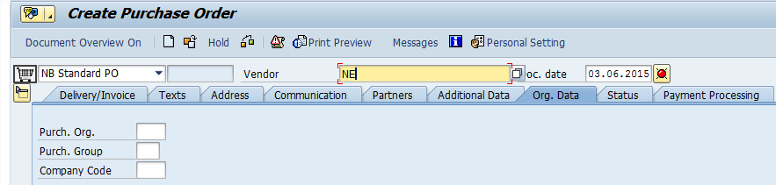

System will show the error at the bottom

Same Case is applicable for material
Enter few initials of Material Master and press enter

System will show error at the bottom

Step 5:-
Click on personal setting Icon
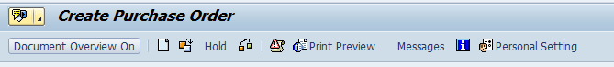

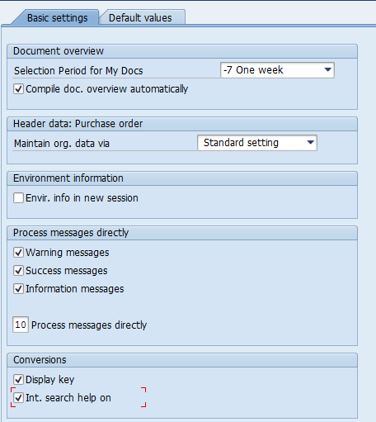

Select the check box of “Int. search help on” under conversions and SAVE

Step 6 :-
Repeat the process again
Enter the vendor initials and press enter

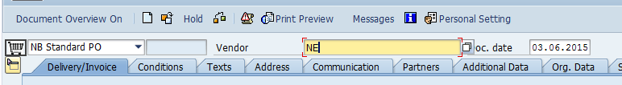
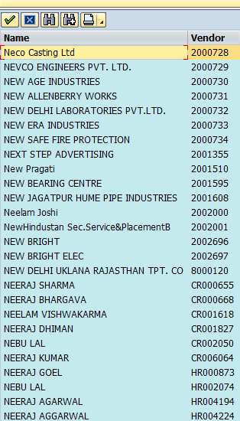

System will display all the vendors having “NE” in it.

Same case is applicable for material field

